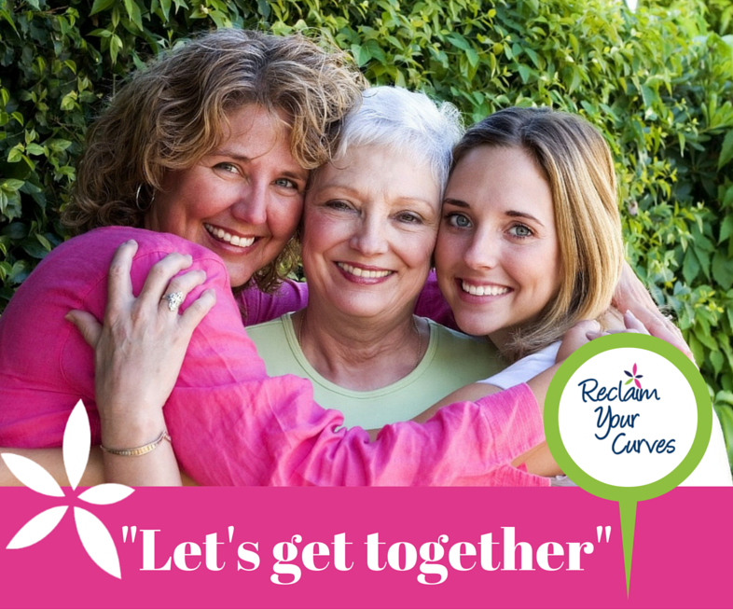
"Have you had to face the trauma of losing your breast/s to cancer?"

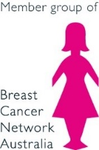
Reclaim Your Curves is a consumer charity informing and supporting women who are making the very personal decisions around breast reconstruction following mastectomy.
Come along & join us for lunch
WHEN: Click here to enter text. Click here to enter a date.
WHERE: Click here to enter text.
YOUR HOST: Click here to enter text. | PHONE: Click here to enter text.
More details…

For more locations and dates go to www.reclaimyourcurves.org.au

